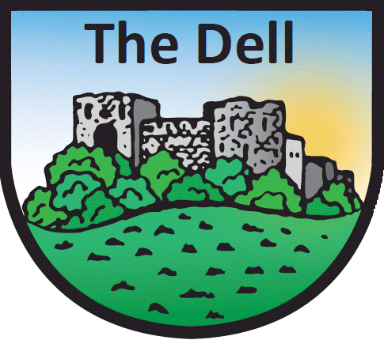
The Dell Primary School
NATIONAL IDENTITY AND ETHNIC BACKGROUND

As a school we are required to seek the following data:

- the pupil’s national identity;
- the pupil’s ethnic background.

National Identity and Ethnic Background

Our national identity relates to which of the national identity groups overleaf we most identify with. Our ethnic background describes how we think of our own ethnicity which may differ from our national identity and may be based on many things, including, for example, our skin colour, language, culture, ancestry or family history. Neither national identity nor ethnic background are necessarily equivalent to nationality or country of birth.

The Information Commissioner has advised that pupils aged 12 to 15 are generally considered capable of deciding their own national identity and ethnic background. It is recommended that decisions regarding a pupil’s own ethnic and national identity, if they are aged between 12-15 years old, are best made with the support and knowledge of those with parental responsibility in a family context. The Information Commissioner advises that pupils aged 16 and over should make their own decisions.

Please study the two sections, A and B, of the form overleaf and tick one box only in each section, to indicate the national identity and ethnic background of the pupil named above. Please also tick whether the form was filled in by a parent or by the pupil.

Please return the form to the school within four weeks, either by post to the Headteacher, or by bringing it into the school office.
The data requested will be stored on the school management information system and used for the purposes outlined in our Privacy Notice. Every effort is made to ensure the accuracy and security of personal data held by the school. Individuals have certain rights of access to personal information held on them; these are outlined in our leaflet “What the School, Local Education Authority and Welsh Assembly Government does with Information it holds on Pupils” copies of which is attached.

The Dell Primary School
NATIONAL IDENTITY AND ETHNIC BACKGROUND RECORD FORM
Pupil’s name Class/Form

Section A: National Identity
Please tick ONE box only and indicate who provided the information below (pupil or parent)
Welsh
English
Scottish
Irish
British
Other (please specify):
I do not wish a national identity to be recorded

This information was provided by:
Parent |  | Pupil

First Language :
(‘ The Language which a child first learned as a small child, and to which s/he may continue to be exposed to at home or in the community’- Welsh Assembly Guidance)

Home Language:
(The language your child speaks at home)

Section B: Ethnic Background (extended categories)
Please tick ONE box only and indicate who provided the information below (pupil or parent)

- White
White – British |  | Kosovan
Traveller of Irish Heritage |  | Latvian
'New' Traveller |  | Lithuanian
Occupational Traveller |  | Maltese
Other Traveller |  | Montenegran
British Gypsy/ Gypsy Roma |  | Polish
Gypsy/Gypsy Roma from Other Countries |  | Portuguese
Other Gypsy/Gypsy Roma |  | Romanian
Albanian |  | Russian
Bosnian-Herzegovinian |  | Scandinavian
Bulgarian |  | Serbian
Croatian |  | Slovakian
Czech |  | Slovenian
French |  | Spanish
German |  | Turkish/Turkish Cypriot
Greek/Greek Cypriot |  | Ukranian
Hungarian |  | White European Other
Italian |  | Other White

- Mixed |  |  | - Asian or Asian British
White and Black Caribbean |  |  | Indian
White and Black African |  |  | Mirpuri Pakistani
White and Asian |  |  | Other Pakistani
White and Chinese |  |  | Bangladeshi
White and Any Other Ethnic Group |  |  | African Asian
Asian and Black |  |  | Kashmiri
Asian and Chinese |  |  | Nepali
Asian and Any Other Ethnic Group |  |  | Sinhalese
Black and Chinese |  |  | Sri Lankan Tamil
Black and Any Other Ethnic Group |  |  | Other Asian
Chinese and Any Other Ethnic Group
Other Mixed Background

- Black or Black British |  |  | - Chinese or Chinese British
Caribbean |  |  | Hong Kong Chinese
Ghanaian |  |  | Malaysian Chinese
Nigerian |  |  | Singaporean Chinese
Sierra Leonian |  |  | Taiwanese
Somali |  |  | Other Chinese
Sudanese
Other Black African
Black European
Black North American
Other Black

- Any other ethnic background
Afghanistani |  | Libyan
Arab |  | Lebanese
Egyptian |  | Malay
Filipino |  | Moroccan
Irani |  | Polynesian
Iraqi |  | Thai
Japanese |  | Vietnamese
Korean |  | Yemeni
Kurdish |  | Other Ethnic Group
Latin/South/Central American

I do not wish an ethnic background to be recorded

This information was provided by:
Parent |  | Pupil

