Dear Parent,
Supporting Vulnerable Children

Our school is ‘all about learning’ and we know that children’s readiness for learning and their ability to excel academically, personally & socially is closely linked to their wellbeing and personal circumstances. At The Dell we want to do all we can to identify pupils who might benefit from additional support to ensure they can achieve as well as their peers. Sometimes we can access additional funding to support these children, but regardless of funding, we still want to ensure that every child has an equal chance to succeed whatever their situation and background. What we know is that children who face challenge, trauma and crisis can’t really give 100% to their learning without a little extra support. This support might be additional adult time or just empathy and an understanding of who they are and their day to day life experiences.

It is very important to us as a school that we are providing the right kind of support at the right time for all children; whether they are looked after, adopted or have at some time experienced trauma or attachment issues that may hinder their progress in school academically, socially or in other ways.

If any of the headings below apply to your child, I’d ask you to complete & return the form below and return it to me. Filling in the boxes below is not statutory but it will help us to best understand your child and ensure that we meet their learning and wellbeing needs, allowing them every chance to thrive.

As with all information we hold, it will be treated in confidence and only used in line with our existing Privacy Notice (available on our website & in our starter pack). In many cases, knowing about this information can help us access additional support and/or funding.

Yours sincerely
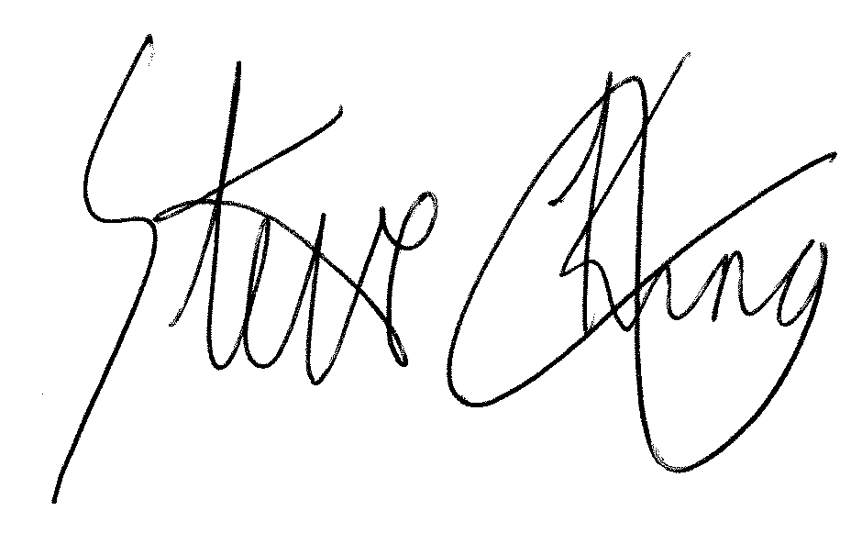
Steve King
Headteacher

Pupil Information Update

Pupil Name(s): Class:

I would like to advise the school that the following apply to the child(ren) named above (currently or ever).
Adopted |  | Service Family |  | Experienced immediate* family bereavement |  | Young Carer**  (registered or unregistered)
Asthma |  | Divorced & Separated Parents |  | Subject to Court Order*** |  | Parent/sibling is or has been  in prison
Medical Care Plan |  | English as an Additional Language |  | Gypsy, Roma or Traveler Community |  | Looked After Child  (foster care or children’s home)
Has ever received support from other agencies
(please give details overleaf)

* = Parent, main carer or sibling. ** = Child is a carer for someone at home *** = Please forward a copy of the Order to the office

If you are happy to add a few notes on the back of this slip / in your email to explain any of the above that you have ticked.

Signed: Name: Date:

