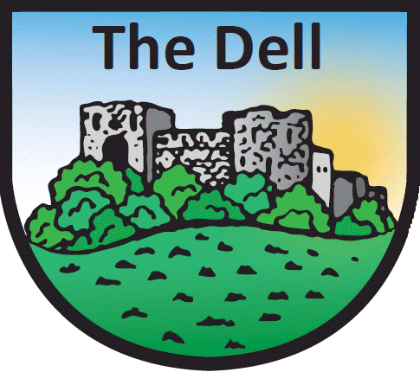
The Dell Primary School
HOME TO SCHOOL TRANSPORT

* * * Only complete this form if your child is eligible for home to school transport * * *

Pupil’s Name: Class:

My child is entitled to free transport to and from school, I have applied to Monmouthshire County Council’s Passenger Transport Unit for a place and and they will be starting to use this method of transport on the morning of

Signed: Date:

