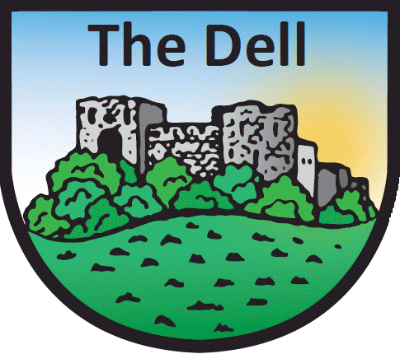

Breakfast Club Registration Form

Child’s Name: | Class:

Special Dietary Requirements

Does your child have any food allergies/intolerance? | Yes | No
If yes, please provide details.

Other Information
Please provide details of any other information you feel relevant your child’s attendance at the breakfast session.

I understand that behaviour deemed unacceptable by the Senior Breakfast Club Leader may result in my child being refused entry.

Signed Date

Reminder – having completed this form:
- Arrival from 8-8.30am is charged and MUST be booked via ParentPay. Only booked children will be admitted
- Attendance from 8.30-8.40am is free and does not need to be booked
- Breakfast Club closes at 8.40am sharp. Children arriving after this time must be supervised by an adult until their entry time. The school takes no responsibility for children’s care (except in Breakfast Club) before their official school entry time.

Please email this form to thedellprimary@monmouthshire.gov.uk
or bring to the office

